**Orbital Maneuvers**

**JS1**

Thus far, only considered orbit characteristics

But, artificial satellites change orbits consider maneuvers and estimate velocity changes required for particular mission objectives

Discussion:

1. Orbit establishment

2. Single impulse adjustments

3. Transfers

1. Orbit Establishment

Relating position/velocity to orbit characteristics

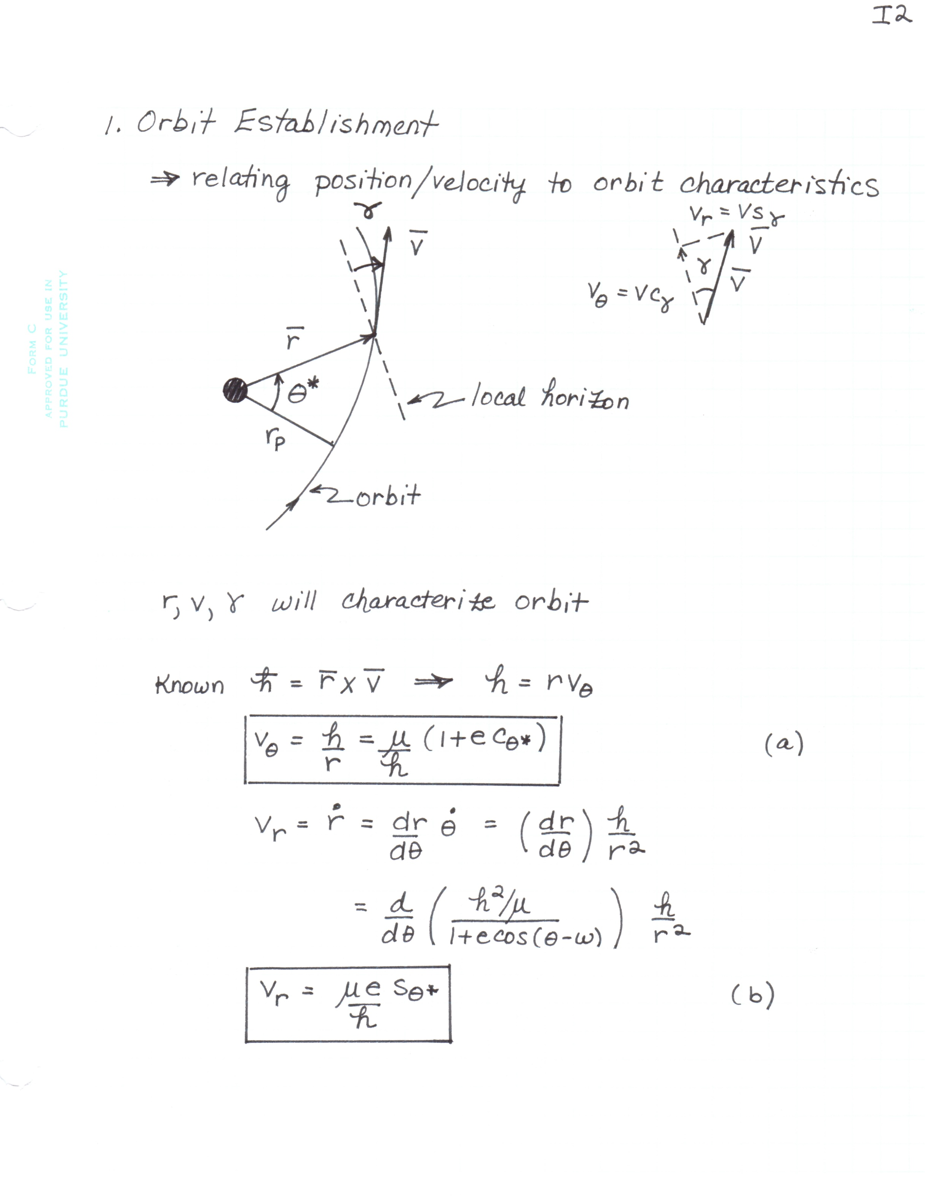

 characterize orbit

**JS2**

Known: 

(JS.1)



(JS.2)

Rearrange (JS.1) and (JS.2)















**JS3**

(JS.3)



(JS.4)

2. Single Impulse Adjustments

**JS4**

Use a single impulse to adjust / change an orbit:

Eliminate launch errors

Bring s/c to a more desirable orbit

Planned correction maneuvers

.

.

.

Note: Transfer to a new orbit with a single impulse is not possible unless the new orbit intersects the original orbit

Assume:

**Example 1**

**JS5**

Satellite in an established Earth orbit: 

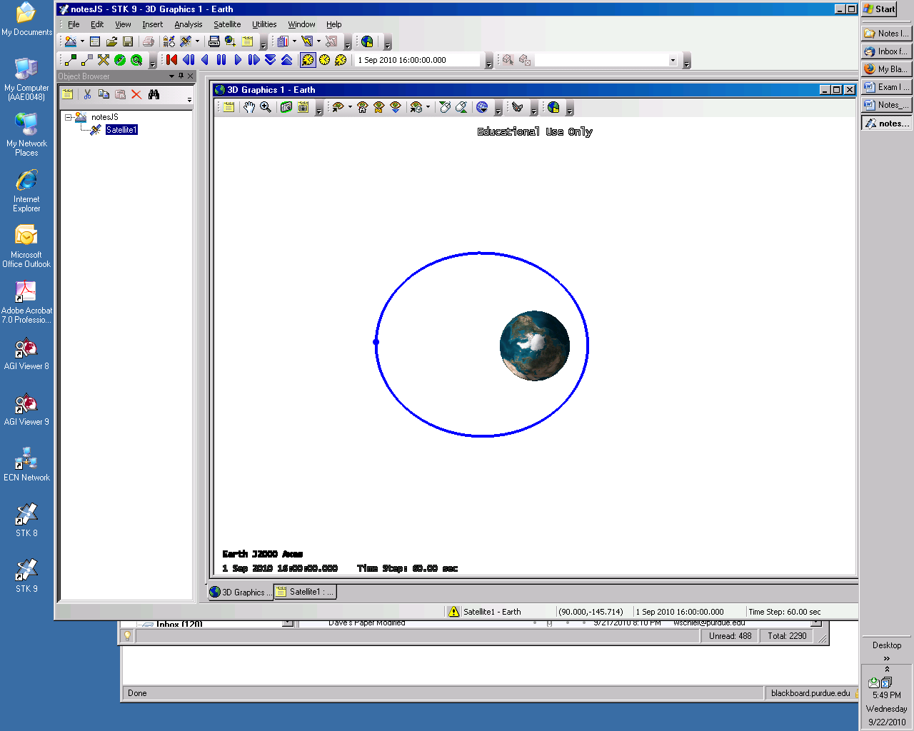

Goal to change orbit subject to:

*e* constant



 (thrust) must be applied at apogee





Determine magnitude and direction of to accomplish goal

Solution

1. Current orbit already established
2. Conditions at thrust point before maneuver/thrust









Note: to increase *a*, likely requires increase in *v*



**JS6**

If increase *v* and maintain same *r*, does *e* change?

Does  change?

Does  change?

1. Determine (if possible) conditions at thrust point after maneuver

 But we do NOT expect this to be apogee in the

new orbit

 given







1. Sketch a vector diagram of the situation

(Choose  for now)







Cosine Law

**JS7**





OR



At angle  wrt initial velocity

Sine law or geometry



Know  

How do I know the quadrant??

Originally

Originally  🡪 Now 

New orbit:

  km/s

 

**JS8**

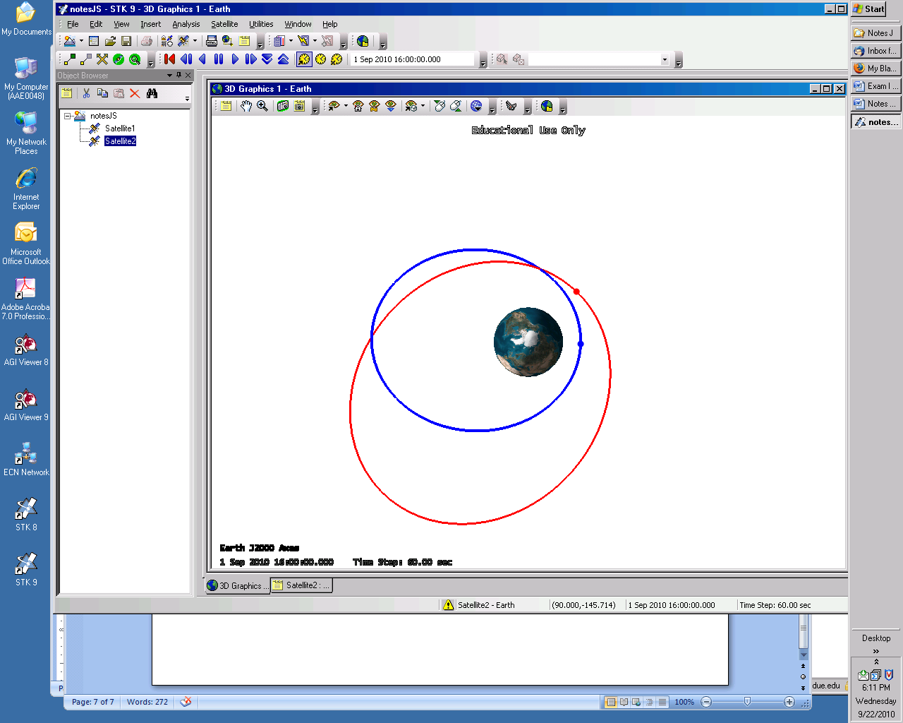







Note: raised perigee

Perigee advanced 🡪 

If 

**JS9**

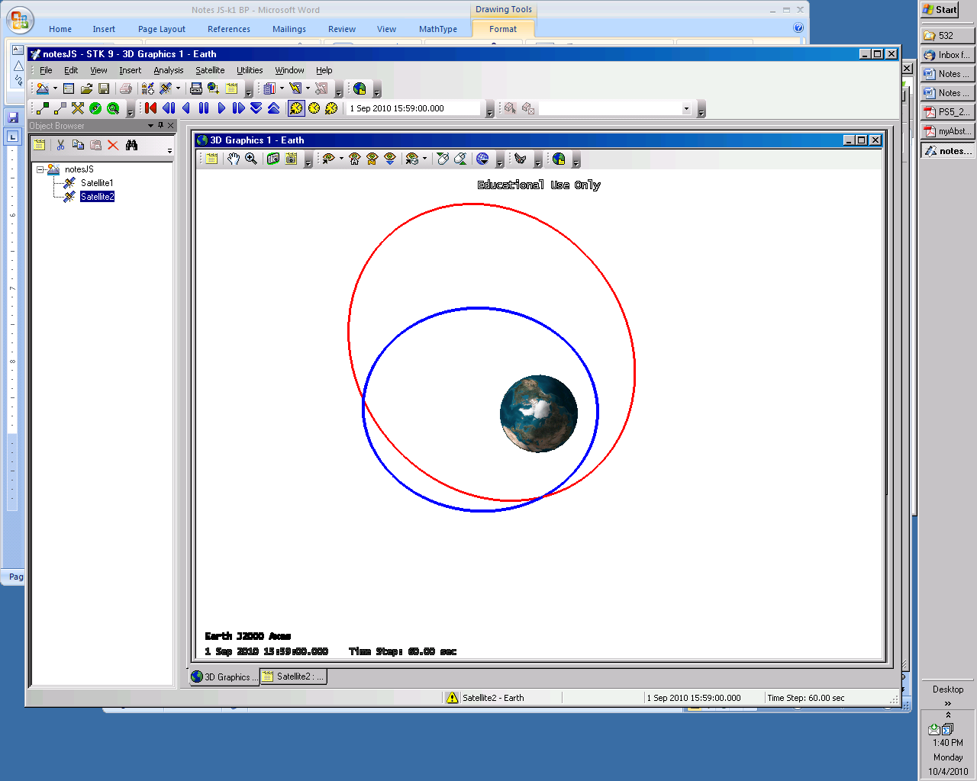

Can same be accomplished for lower cost?

**JS10**

Put maneuver in a different location?

Currently: 



Maneuver at 

 constant









Solution

1. Current orbit already established
2. Conditions at thrust point before maneuver/thrust



 km/s



Consider how to accomplish objective –

Increase/decrease velocity?



Is a tangential  possible?



1. Desired conditions after maneuver

**JS11**



km/s



1. Vector diagram

Sketch a vector diagram of the situation

(Choose  for now)

Cosine Law





Sine Law







**JS12**

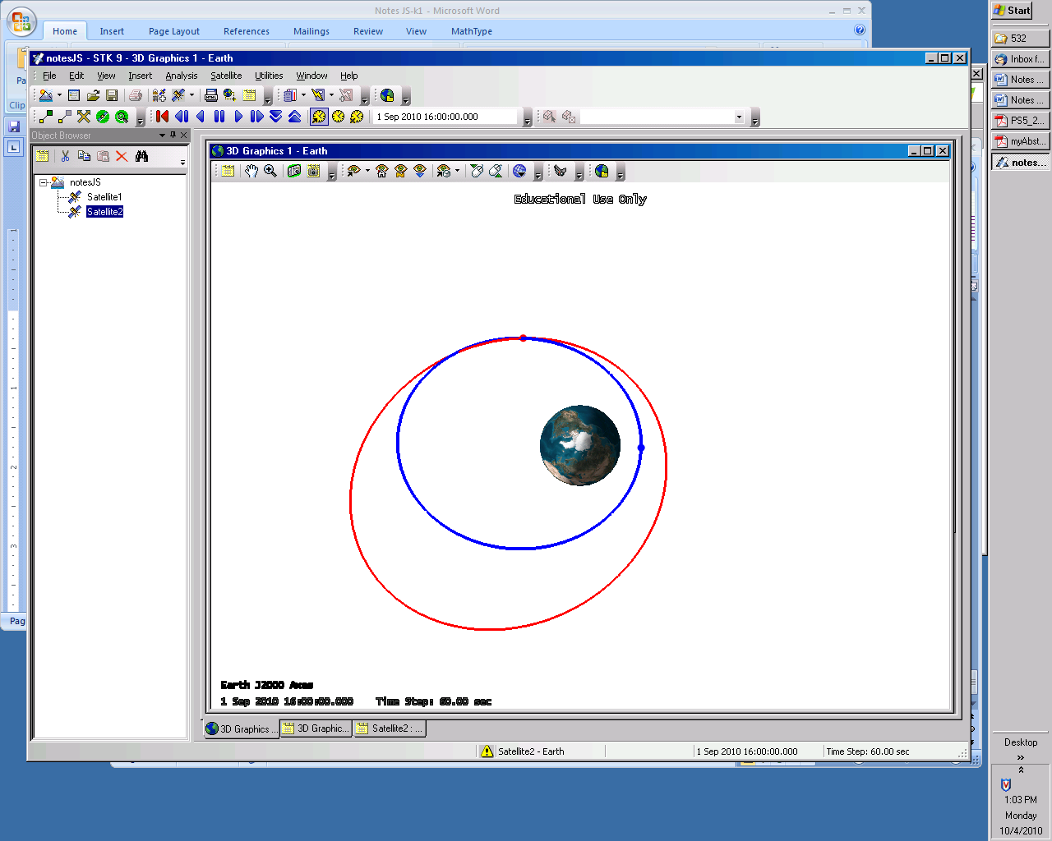

**Example**

**JS13**

At a certain instant, an Earth observing satellite is described in terms of the following state



At this point, a maneuver such that  and . Determine the final orbit.

Solution:

1. Establish current orbit / current location



1. Conditions immediately prior to maneuver are given

Add :





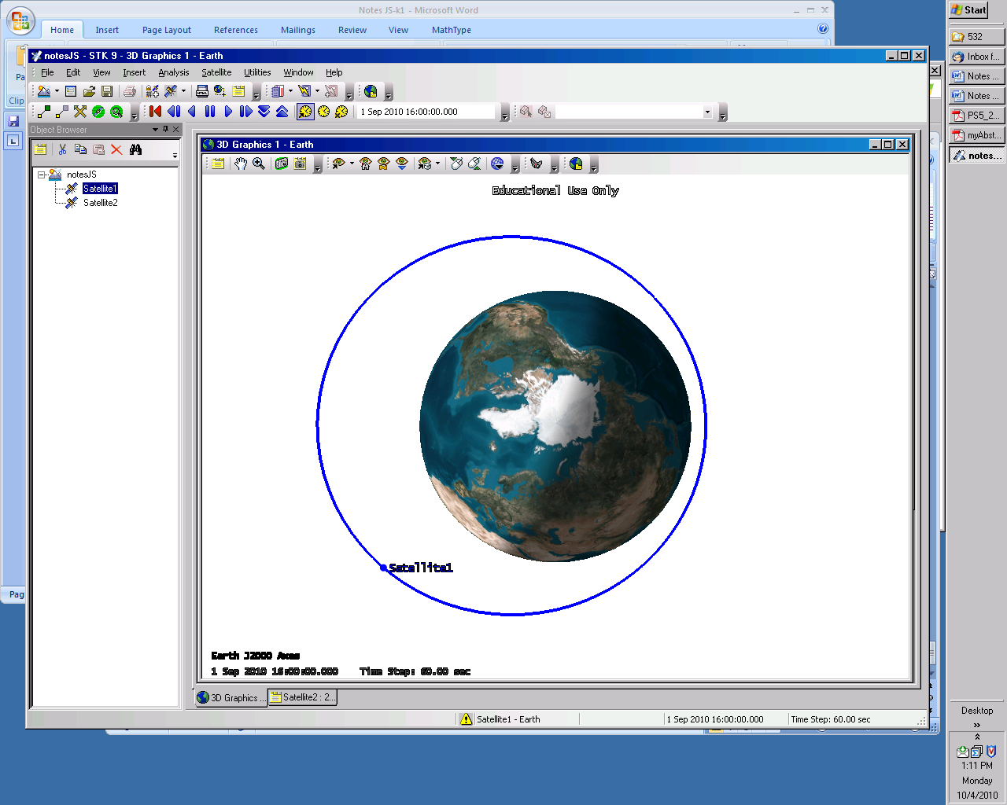

1. Conditions immediately after the impulse

**JS14**



Cosine Law





1. Establish the new orbit

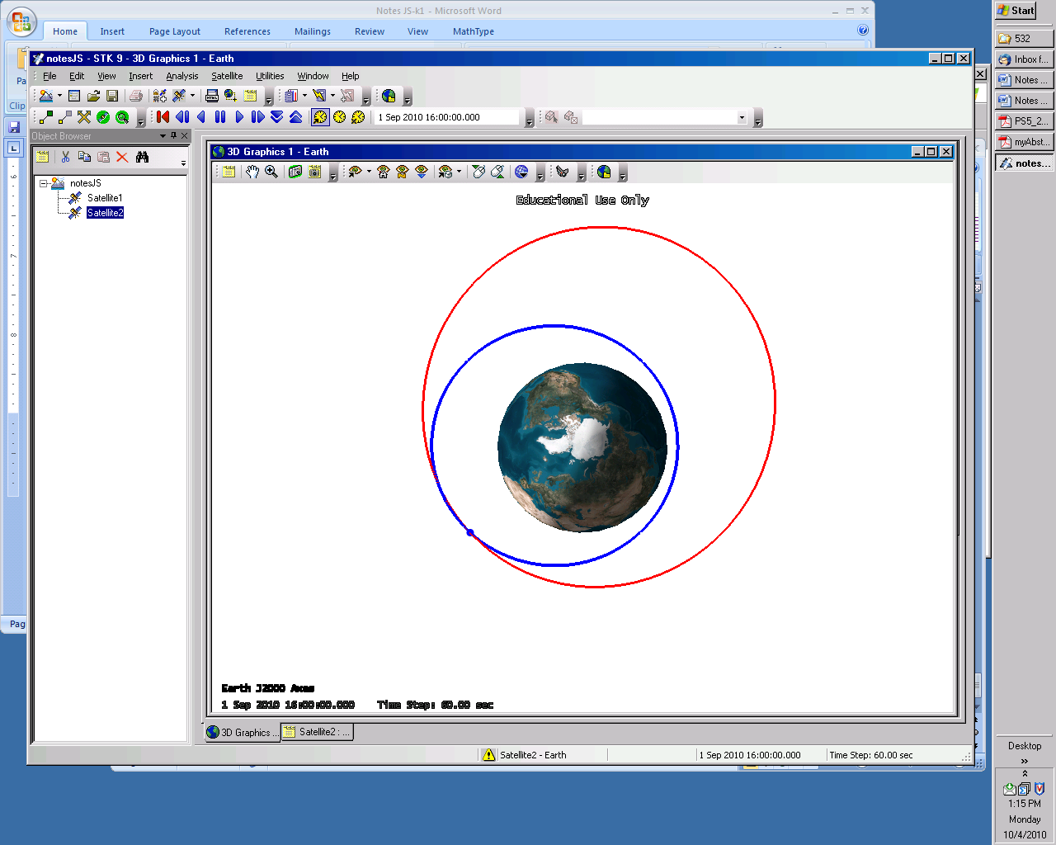

**JS15**